**Computing the Maximum Cut**

***A Branch and Cut Algorithm***

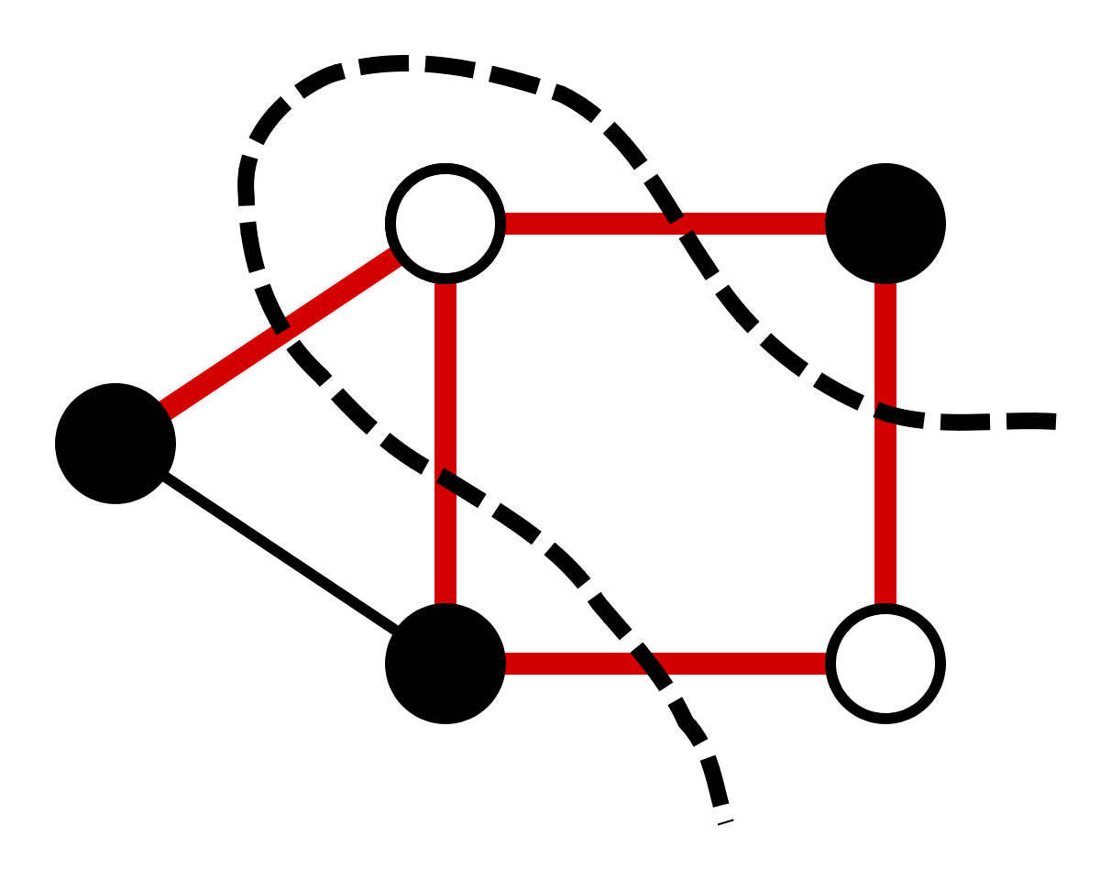

Sakibul Alam

*Emory University 2015*

*Rice University 2017*

Alex Gardner

*Rice University 2018*

Vincent Gonzales

*Rice University 2019*

***Table of Contents***

1. *Introduction………………………………………………………………………………………………. 3*
2. *The Algorithm ………………………………………………………………………………………….. 4*
   1. *Branch-and-Cut Technique*
   2. *Our Implementation - Generating Valid Cuts*
   3. *Lower Bound Heuristic*
3. *Computational Results ……………………………………………………………………………… 7*
   1. *Implementation and Run Time Results*
   2. *Computational Summary*
4. *Future Work …………………………………………………………………………………..………... 8*
5. *Concluding Remarks ……………………………………………………………………………….… 8*
6. *References ……………………………………………………………………………………………… 10*

***Introduction***

***Branch and Cut Algorithm***

*Branch and Cut Technique*

By solving a linear program by branch and cut, we initially solve the LP relaxation of a program typically formulated as an integer program without any cut constraints. Then after solving the initial relaxation, we add odd cycle cutting constraints to our model necessary to remove limit infeasible, fractional max cuts. Then we re-solve the LP relaxation with these added constraints, find a fractional decision variable, and branch on that variable. In branching we create two new linear programs, each with a new constraint: one that forces the found fractional variable to zero and the other forcing the fractional variable to take on a value of one. We repeat this until there our queue of models is empty and we have solved the maximum cut problem. The general procedure for solving the max cut via branch and cut is summarized as follows:

* + - 1. Solve the LP relaxation of the Max Cut problem without any odd cycle constraints. In general, the optimal solution, x*, will not be integer-valued for all decision variables at this point.
      2. Find odd cycle cutting constraints for every node in the graph, using x* as the edge-weights on our odd cycles. Cuts with odd cycle weight greater than one less than the size of the cycle will become the odd cycle cutting constraints.
      3. Add these cuts with weight greater than the size of the cycle minus 1 to the initial LP relaxation and re-solve it.
      4. Chose a non-integer variable, *x*k* and branch from it. When we branch on a variable, we create two copies of our original LP, one where *x*k* ≤ 0 and another where *x*k* ≥ 1.
      5. In each branch, re-solve the new LP and return to step 2. Finish when x* is integer, there are no violated odd cycle constraints and there are no models remaining to compute solutions to.

*Our Implementation – Generating Valid Cuts*

Valid Cut generation piece goes here

*Lower Bound Heuristic*

Our lower bound heuristic does very little in actually limiting the number of computations that we run in the branch and cut stage of the implementation. We note that as we are computing the maximal cut of a graph, and other valid cut forms a valid lower bound on a given graph’s maximum cut. Thus, we can naively compute a feasible solution at the beginning of the algorithm that will form a lower bound on the maximum cut value. In theory, with this bound we no longer need to visit as many branches as we would otherwise. This is because any branch that produces an optimal cost lower than the best cost for a previously found integer solution terminates the current branch. The following implementation is particularly naïve and in many cases, it does not make the algorithm terminate any faster than it otherwise would; it is far more likely that we will find a higher lower bound within the first few stages of the branch and cut algorithm, thereby improving our lower bound almost immediately.

To compute an initial feasible solution, we create an arbitrary partition in the graph using a ½-approximation greedy algorithm. In this we assign each of the nodes to be in one of two sets with equal probability. It is the separation between these two sets that forms our partition that we utilize for our initial feasible solution. This solution is clearly integer as we set all of the edges between the two sets to take on a value of one and all others to take a value of zero. We then add all of the edges that go between the two sets to set our initial lower bound.

***Computational Results***

*Implementation and Run Time Results*

We implemented our solution in Python using Gurobi and ran all tests on a Late-2013 Macbook Pro with the following specifications: 2.6GHz Intel i5 Processor, 8GB RAM @ 1600 MHz DDR3. The results and run times for the TSP instances are shown in the table below.



The next table below summarizes the results for the planar graph instances we tested.



*\*All run times were gathered from our tests on the Macbook Pro mentioned above*

*Computational Summary*

The majority of our test cases completed after just one iteration, meaning that our algorithm never entered the branching phase. This was expected with the planar graphs as by definition they are weekly bipartite. Completing the algorithm in one iteration indicates that we add all of the necessary odd cycle cut constraints in the first iteration. However, on some of the larger graphs with hundreds of nodes and over one thousand edges, adding cut constraints became extremely time consuming. As a result, we concluded that while our method of adding cuts is effective in reaching the solution, it is likely making our solution computationally slower than it could be. The number of potentially violated cut constraints increases exponentially as the number of nodes and edges increase. As a result, we notice that the runtime increases exponentially as well, though more than we were anticipating for even the large planar instances.

Even though the planar graphs all finished after one iteration, our implementation performed best on the smallest TSP instances, gr21 and ulysses22 with both completing in under 1.6 seconds. Ulysses22 also completed in just one iteration as no branching was necessary to deliver the optimal solution. Gr21 took only five iterations, indicating that adding our initial set of cuts is our most time-intensive process. This furthers our suspicion that the solve time increases exponentially as the number of nodes and edges increases in a graph. As such, gr21 and ulysses22 have only 21 and 22 nodes respectively, and solutions were found quickly as a result. In considering the remaining travelling salesman instances, att48 and hk48 both solved to optimality in 1 iteration in just under a minute. Again, from just the travelling salesman instances alone we could deduce that process of adding all of the cut constraints initially is our most time intensive process.

Now we consider our planar test instances. As all of these completed in just one iteration, it is clear that we add hundreds of cuts in the first iteration which causes a bottleneck of sorts as a result. While we expected some of these instances to take a long time to complete due to their relative size, we were not expected our largest instances to take several hours to solve to optimality. This is likely due to Dijkstra’s algorithm. As we previously mentioned, in order to find the shortest odd cycle in a graph we build a “pseudo-graph” and use Dijkstra’s algorithm to find a shortest *(v, v’)*-path. In the largest instances, we do this thousands of times before we even branch. We run Dijkstra’s algorithm n times (where n is the number of nodes in the graph instance), before every optimization step. Then after we optimize, we run it n more times and repeat. We stop this process and branch when we go through the entire set of odd cycle constraints only to find that none of our found generated constraints are feasible. Running Dijsktra’s algorithm potentially hundreds of thousands of times on large instances is not feasible in practice, but it solves smaller instances to optimality quickly.

***Future Work***

***Concluding Remarks***

***References***